**NAME:** KARTHIKA S

**MAIL-ID:** [karthikas@bitsathy.ac.in](mailto:karthikas@bitsathy.ac.in)

**INSTITUTION NAME:** Bannari Amman Institute of Technology ,

Sathyamangalam,Erode(District)

Tamil Nadu - 638401

**COURSE TITLE:** Applied Data Science

**PROJECT TITLE:** Effective Heart Disease Prediction Using IBM Auto AI Service

**SCREENSHOTS OF PROJECT:**

IBM CLOUD DASHBOARD

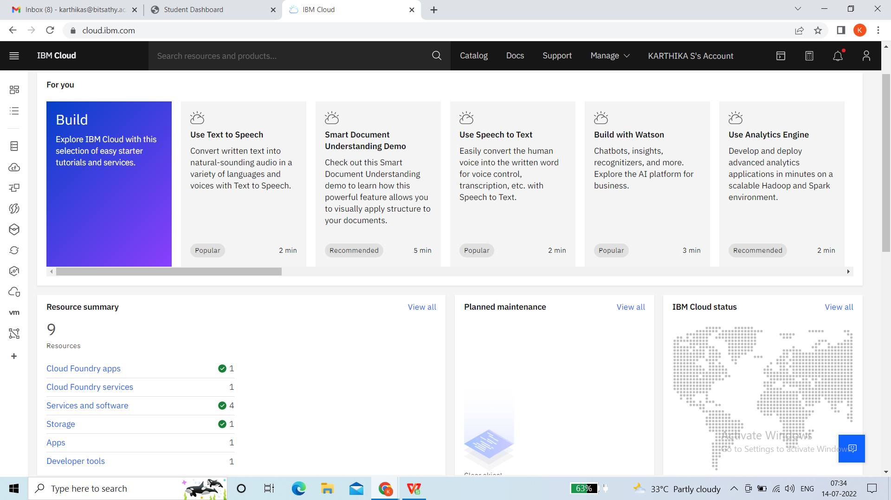

**SERVICES AND SOFTWARE INSTALLED**

IBM CLOUD(INCLUDES WATSON STUDIO,MACHINE LEARNING,NODE-RED) – RESOURCE LIST

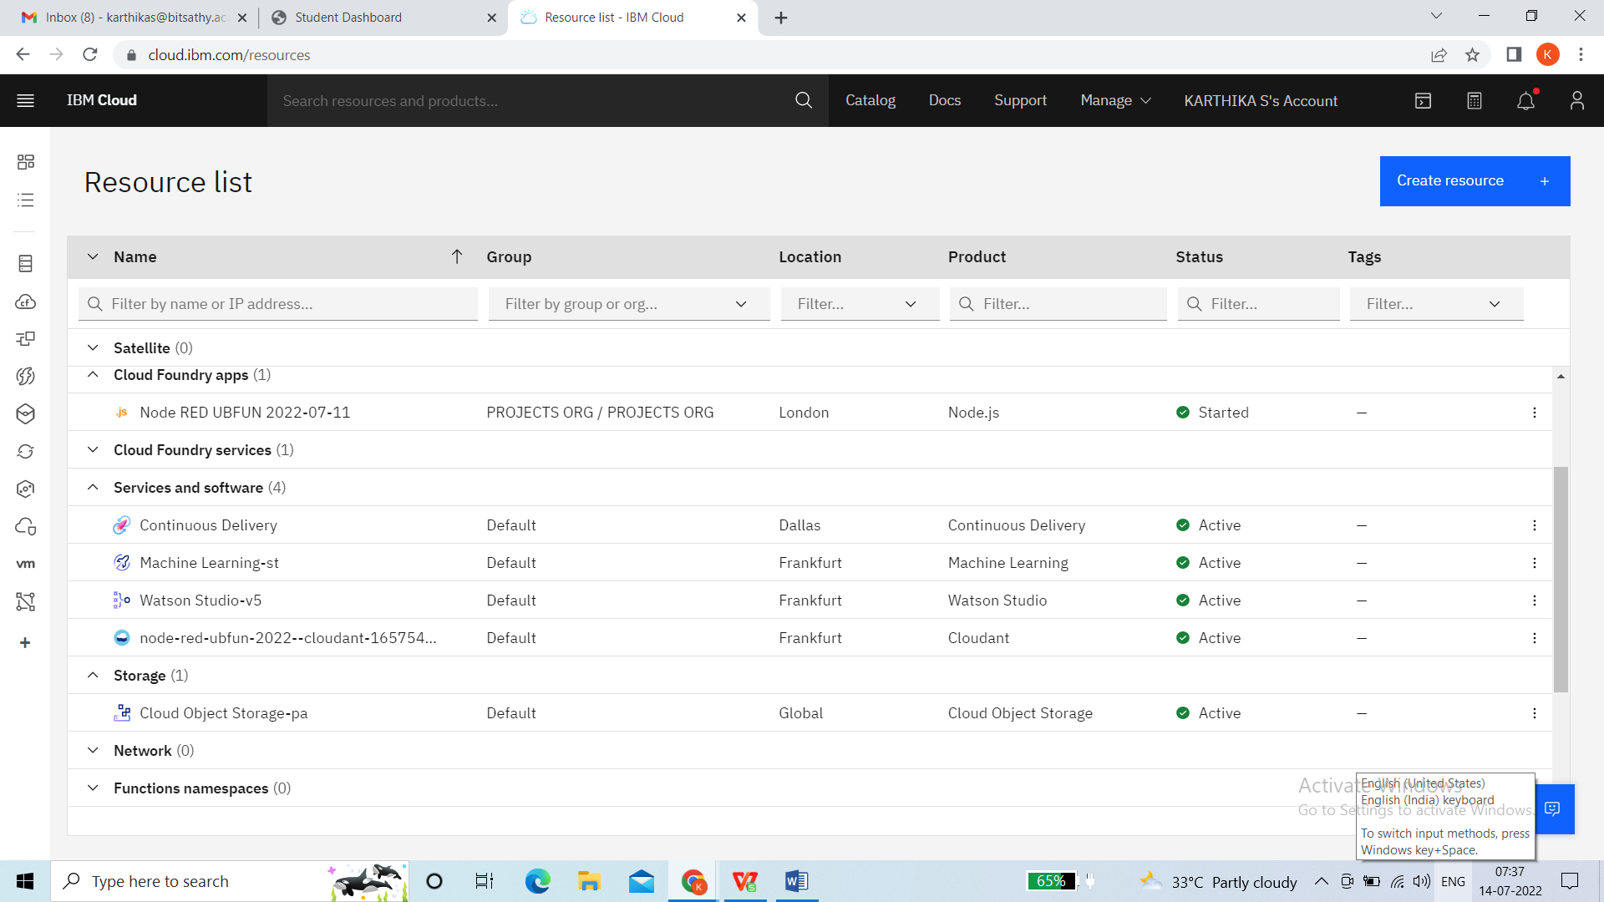

WATSON STUDIO (LAUNCH)

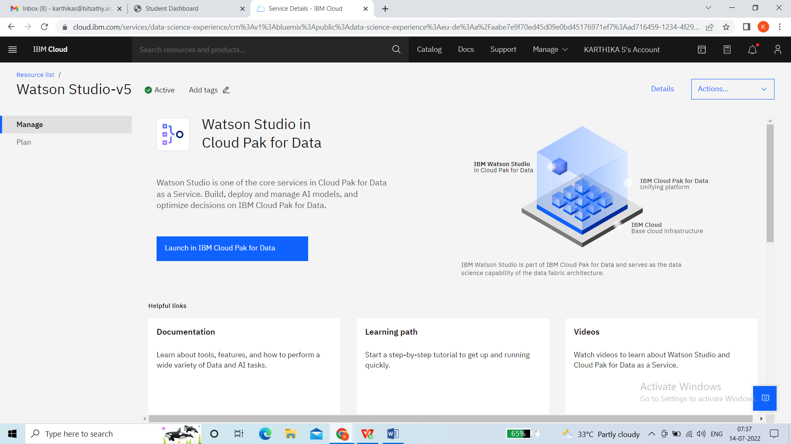

CREATING WATSON STUDIO

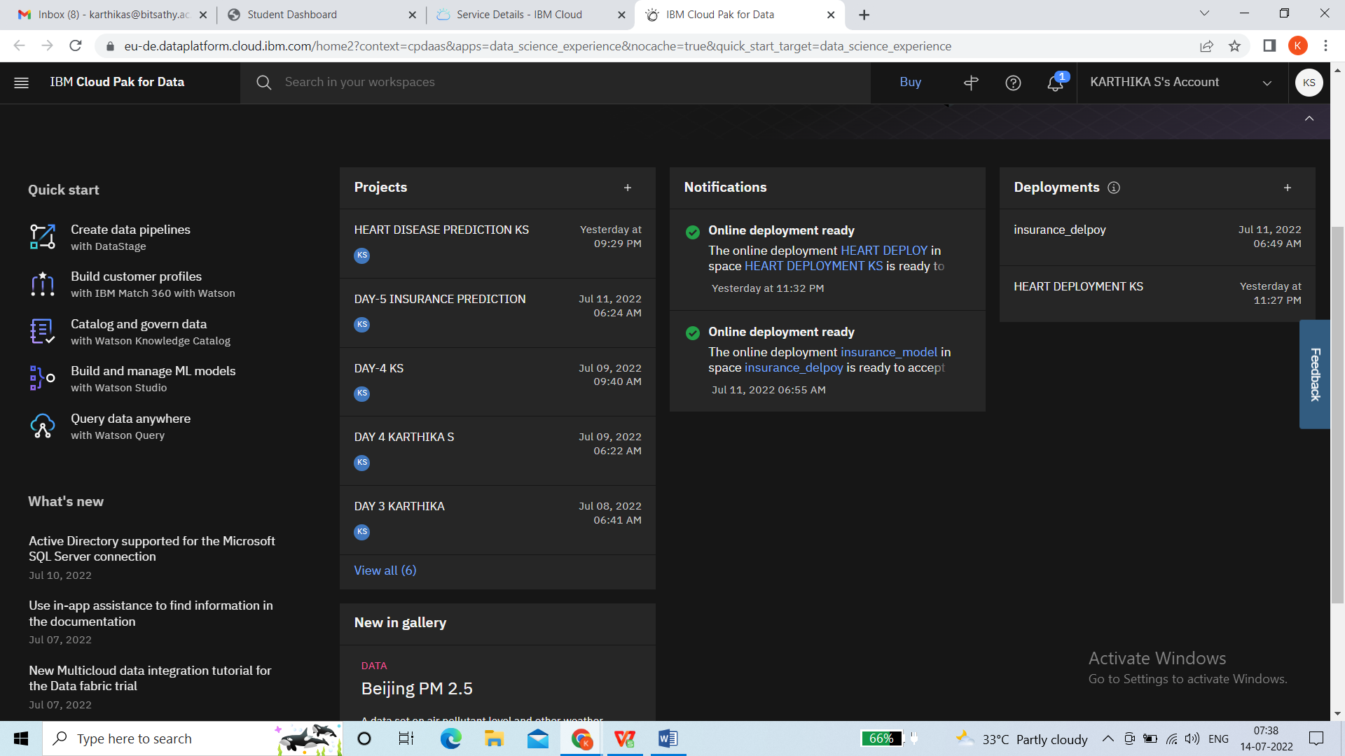

OVERVIEW PAGE

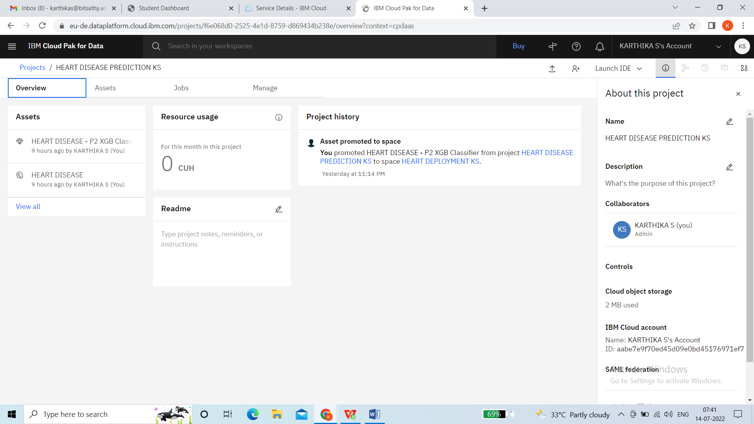

ASSESTS FOR HEART DISEASE

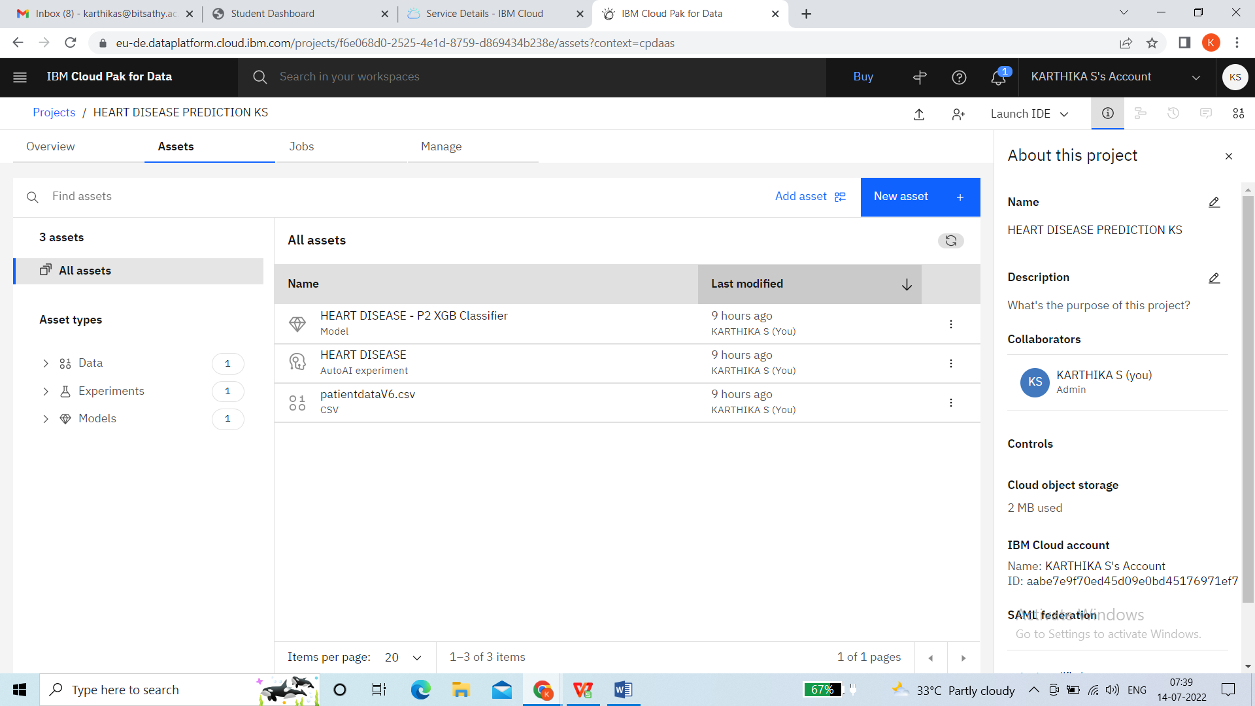

DEPLOYMENT SPACE (HEART DISEASE)

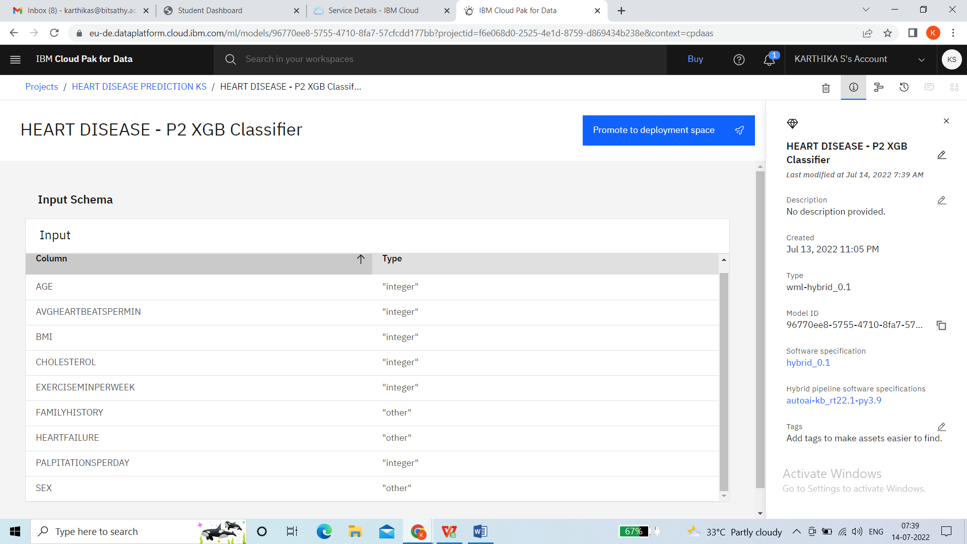

DEPLOYMENT NOTIFCATION

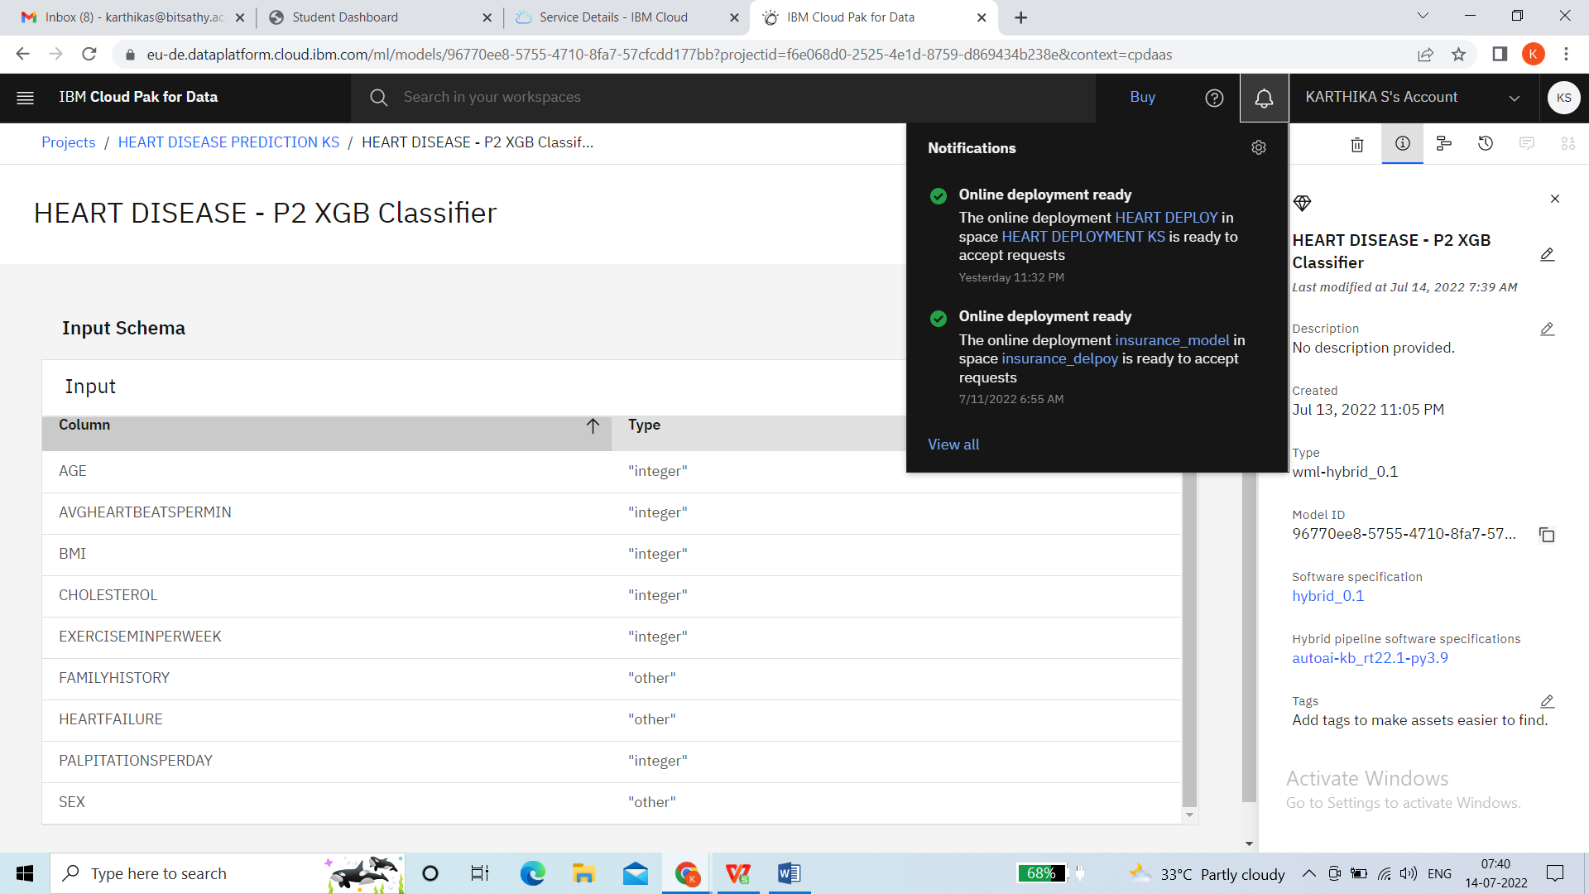

HEART DISEASE PREDICTION (MANAGE TAB)

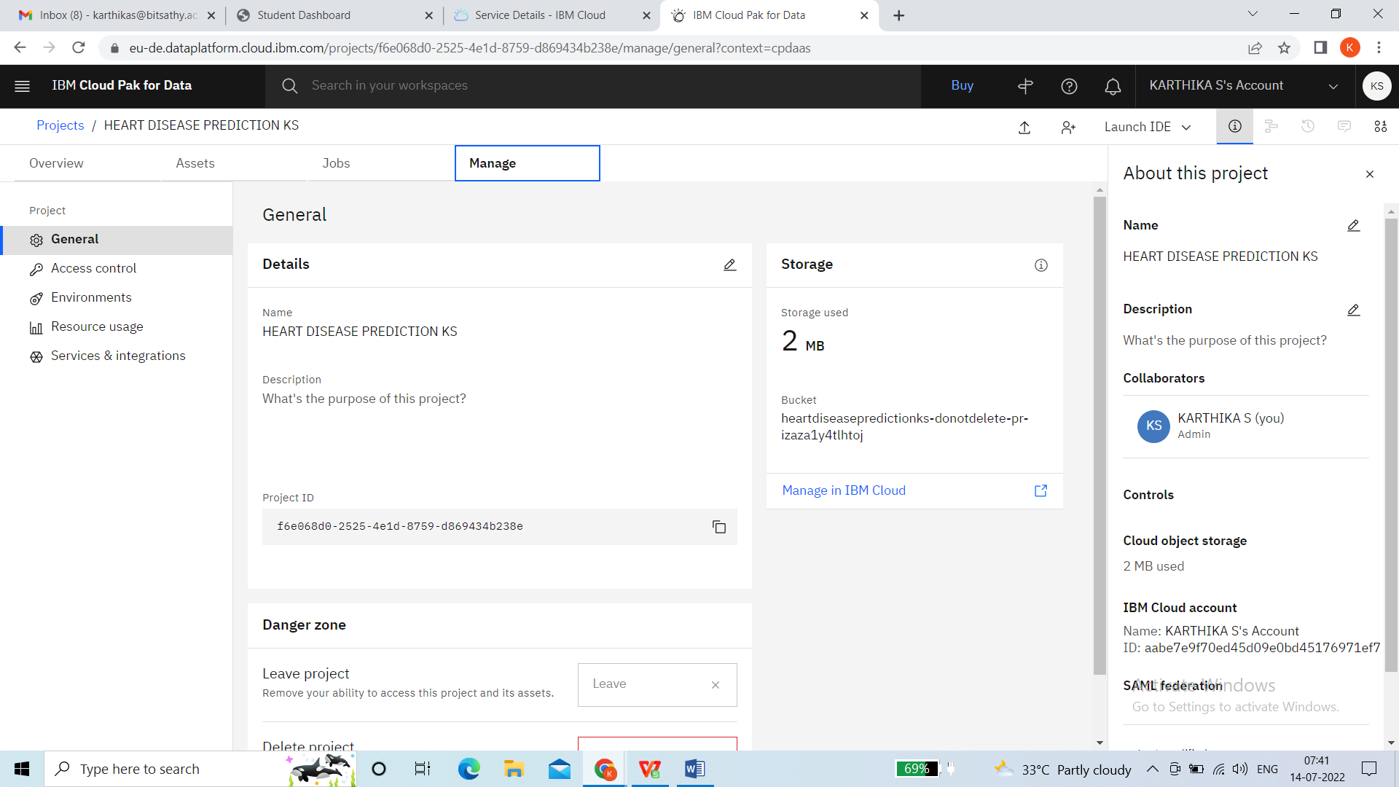

POJECTS DONE

EX: HEART DISEASE PREDICTION KS (FILE NAME)

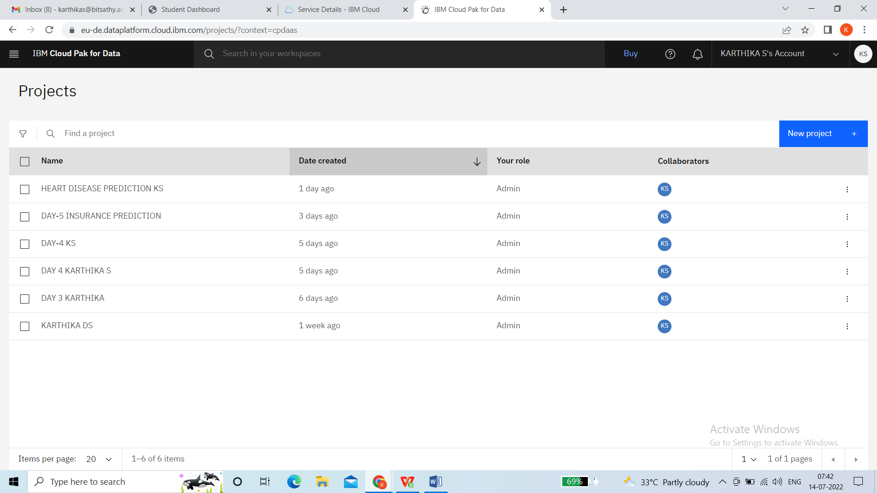

SPACE ACTIVITY

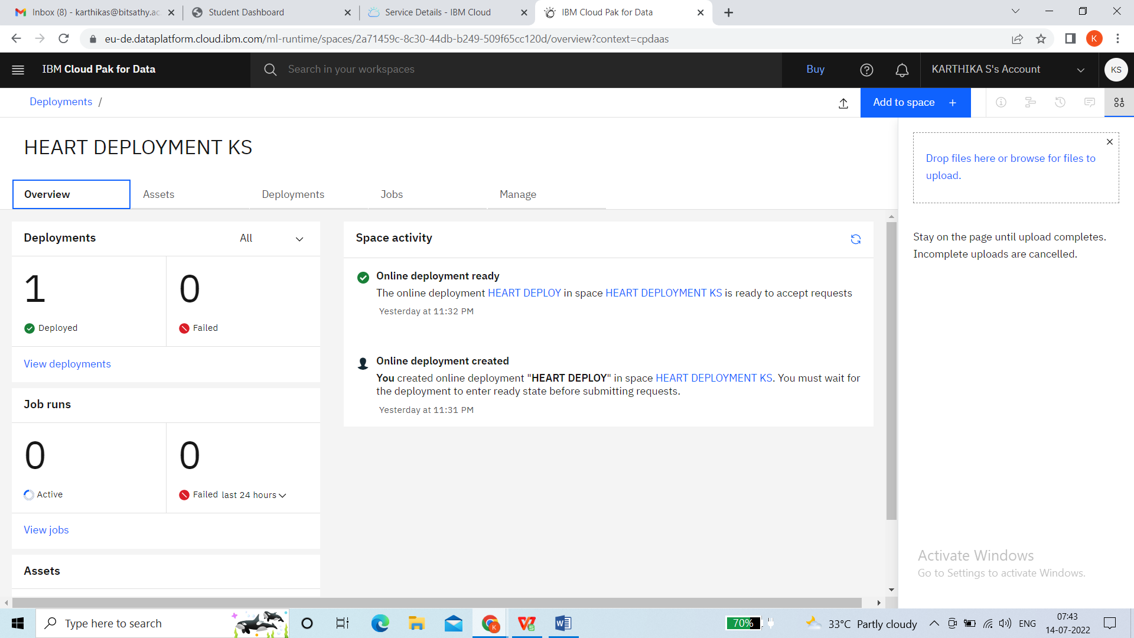

HEART DEPLOYMENT (ASSESTS)

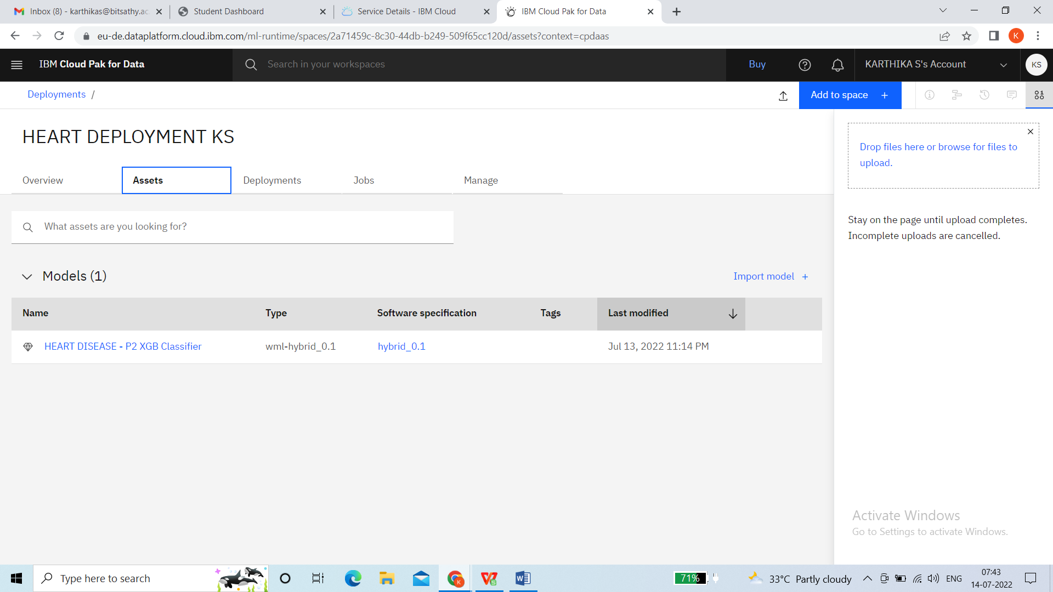

HEART DEPLOYMENT KS (CREATED/DEPLOYED)

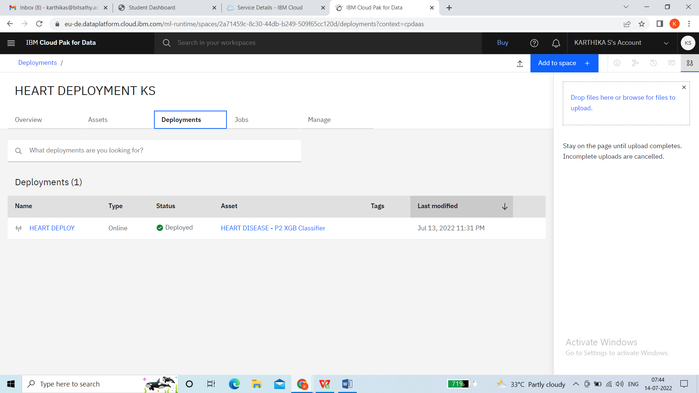

MACHINE LEARNING DASHBOARD

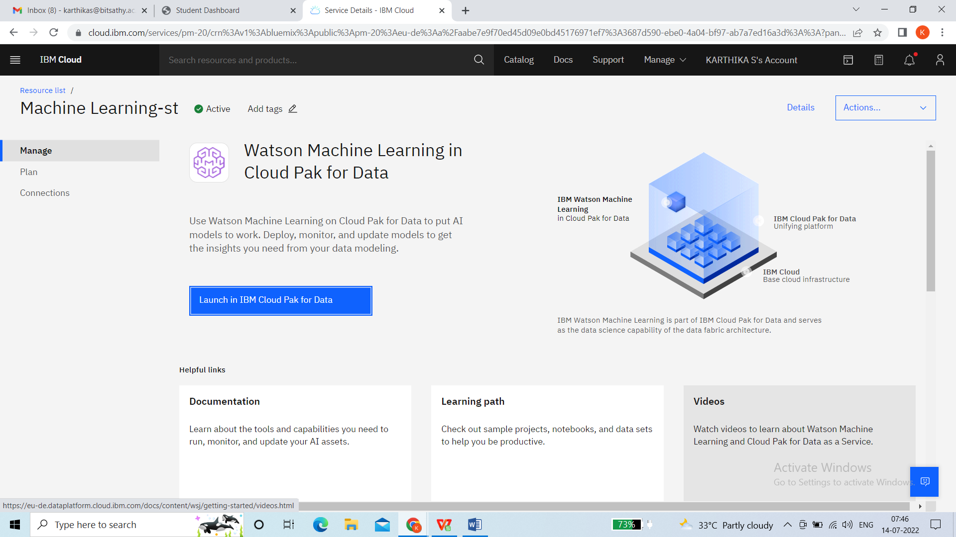

NODE RED APP

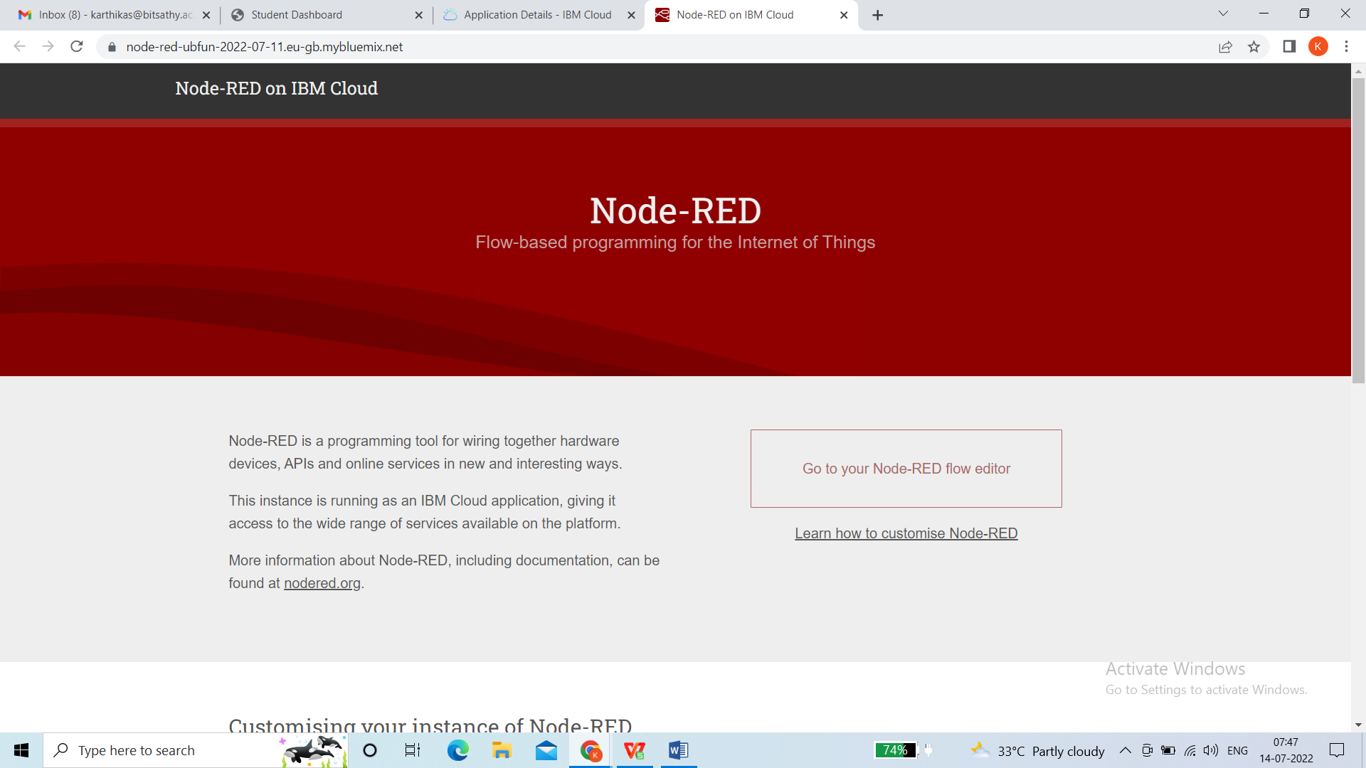

NODE RED DASHBOARD

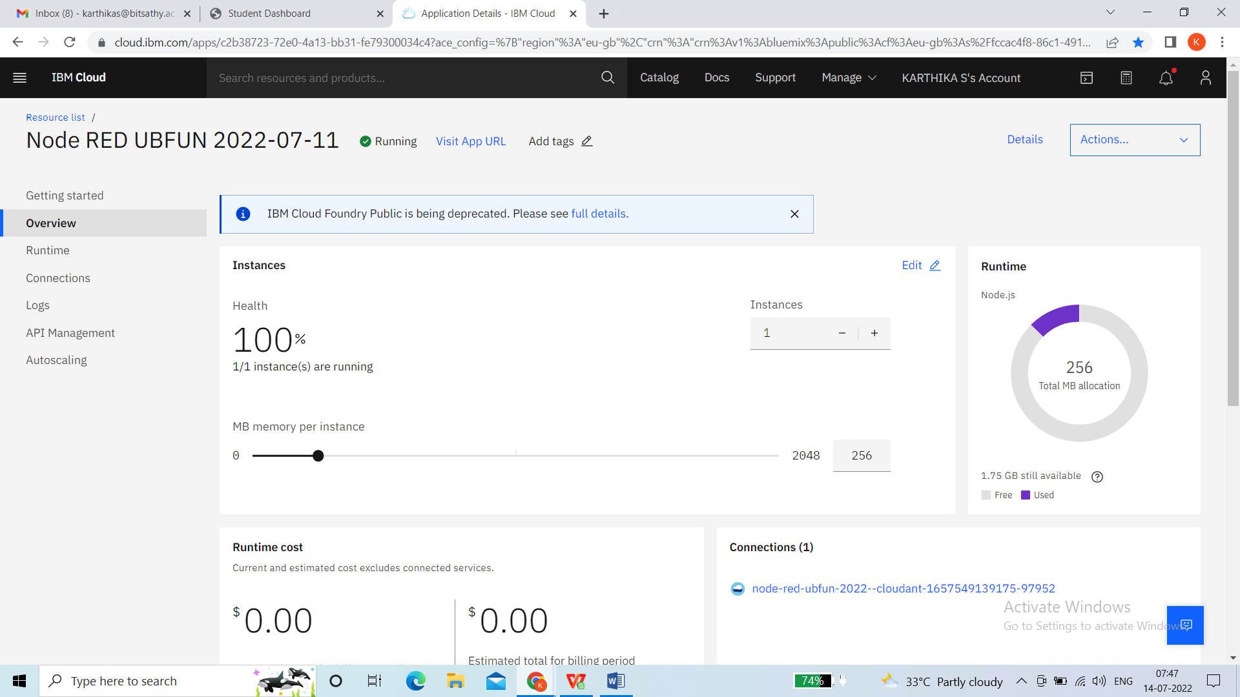

NODE RED (JSON FILE)FUNCTION

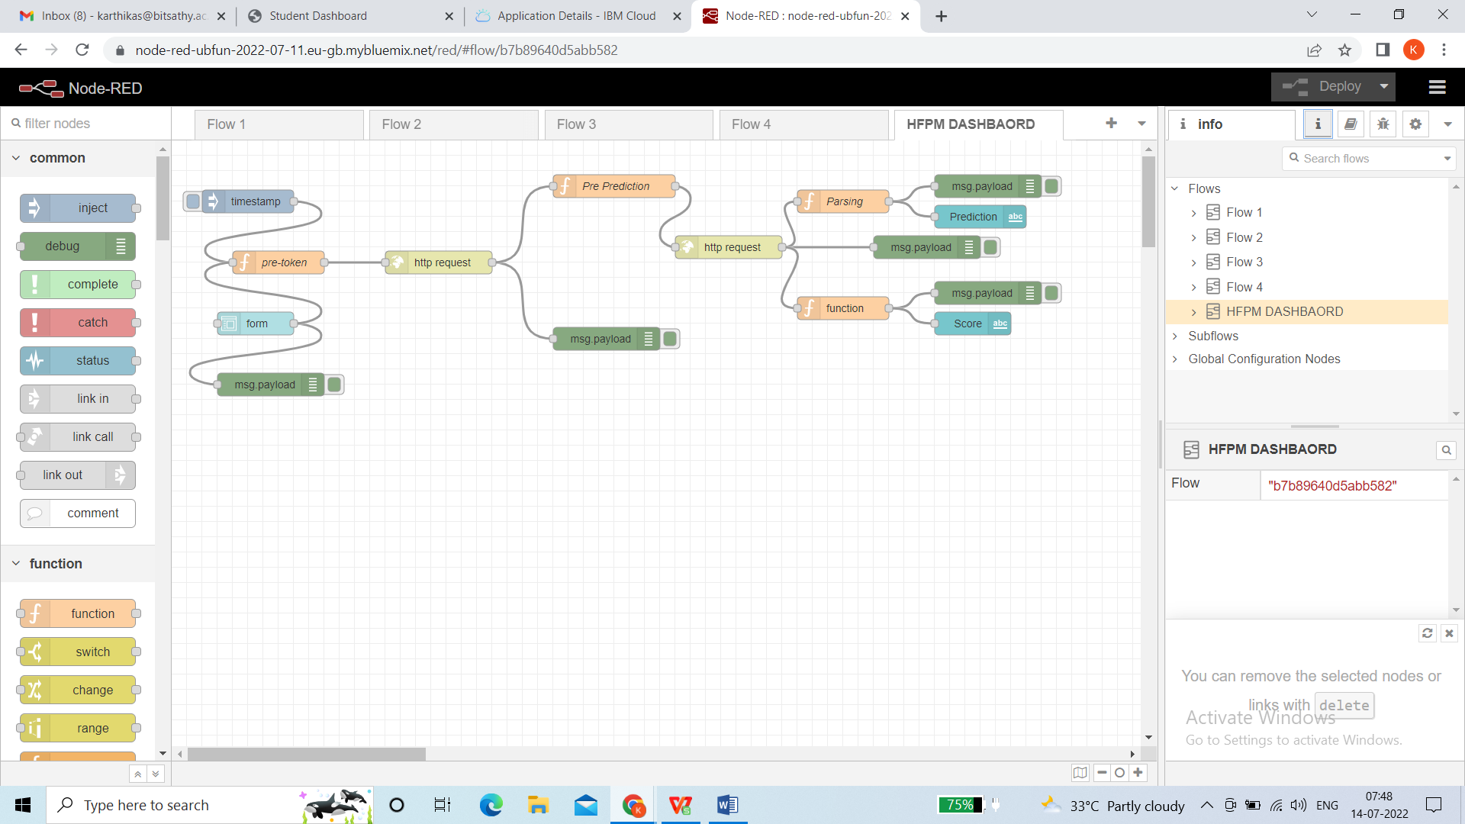

HEART DISEASE PREDICTION OUTPUT 1:

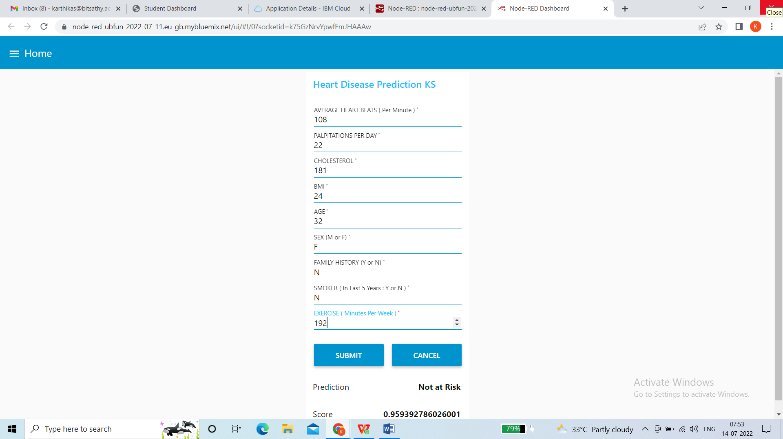

HEART DISEASE PREDICTION OUTPUT 2:

